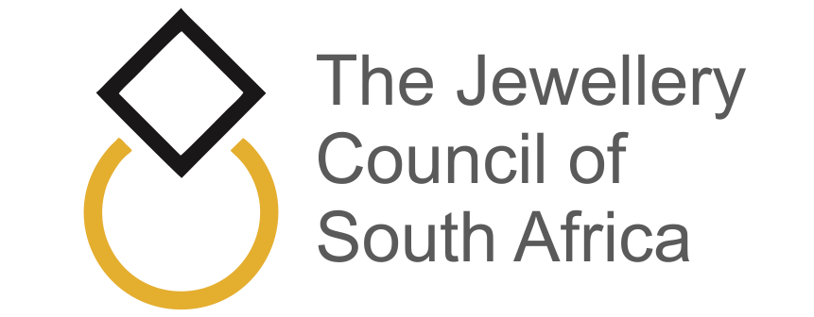
The Jewellery Council of South Africa 2 Le Paradis 3 Oak Avenue Bedfordview 2007

Exhibition Name:
4 – 8 March 2026
HKTDC Hing Kong International Jewellery Show
Exhibition Dates:
The Jewellery Council of South Africa
Organizer:

Agreement:
- I hereby confirm that my company is established in South Africa and is export ready.
- I confirm that I am able and capable to attend the event.
- I confirm that I have read and fully understand the SSAS Emerging Exporters Guidelines:
http://www.thedtic.gov.za/wp-content/uploads/SSAS_Emerging_Exporters_Guidelines.pdf
and
http://www.thedtic.gov.za/wp-content/uploads/SSAS_Interpretation-Note_01-of-2021_Annexure-A.pdf
  - I confirm that I meet the qualifying criteria of the SSAS Emerging Exporters Guidelines.
  - I confirm that I have read and understood the mandatory requirements as set out in the SSAS Emerging Exporters Guidelines.
  - I further acknowledge and understand the limitations and exclusions for funding as set out in the SSAS Guidelines for Emerging Exporters.
- If for any reason, I am unable to travel, I will inform JCSA (Jewellery Council of South Africa) immediately.
- I am able and capable to attend the event/s applied for, before submitting any application or claim.
- I have ensured that I have equipped myself with relevant health precautions prior, during and after the event.
- I fully agree to adhere to and meet all Covid-19 regulations and protocol for travelling and entering the hosting country and returning to South Africa.
- I assume full responsibility for my health and infectious disease exposure, consequences and all costs relating to such and indemnify DTIc, and the project co-ordinator of all responsibility and all related cost hereto.
- I agree to personally cover all costs regarding Covid-19 testing as per hosting country regulations for travel, entry and exit and ALL additional costs relating to Covid-19 including health related expenses.
- I hereby confirm that I am fully vaccinated against Covid-19 and have a valid e-Vaccination Certificate.
- In the case where additional traveller(s) not sponsored by the DTIc are accompanying me the exhibition, I will take full responsibility for ALL costs endured including Covid-19 related costs (testing and in the case of disease exposure and or consequences) and indemnify DTIc and the project co-ordinator of all said and related costs and responsibility.
- I understand and agree to the DTIc generic and standard conditions:
  - the DTIc will not be responsible for additional expenses that may arise out of the lockdown restrictions that the host country or any relevant authority may impose.
  - the DTIc will not be held responsible for any health-related expenses, suffered by the travellers.
  - the DTIc will only be responsible for the approved amount that covers the event/ exhibition as per the approved guidelines.
  - The project co-ordinator shall be indemnified on clause 1.1, 1.2 and 1.3.
- I hereby give full authority to JCSA (Jewellery Council of South Africa) to represent me with this application for the SSAS funding for emerging exporters scheme and to correct and compile this application on my behalf.
- I confirm that I am fully aware that JCSA (Jewellery Council of South Africa) and the DTIc will rely on the accurate/complete and truthful information contained in all documents provided for application purposes to process and evaluate the application of the Individual Participant.
- I confirm that all the information I provide to JCSA (Jewellery Council of South Africa) and submitted to the DTIc is correct and truthful and that this declaration binds me/us to liability in civil and criminal consequences should the information be found to be misleading, and/or incorrect and/or inaccurate and/or is a result of a misrepresentation.
- I agree that I/my company takes full responsibility for any civil and criminal consequences should any information I provide to JCSA (Jewellery Council of South Africa) and submitted to the DTIc be found to be misleading, and/or incorrect and/or inaccurate and/or is a result of a misrepresentation.
- I agree to full indemnity towards JCSA (Jewellery Council of South Africa) in the case where legal, civil and criminal consequences are taken against me should any information I provide to JCSA (Jewellery Council of South Africa) and submitted to the DTIc be found to be misleading, and/or incorrect and/or inaccurate and/or is a result of a misrepresentation.
- I acknowledge that should any information in the application form or supporting documents respectively be inaccurate or misleading or contain fraudulent information and /or have potential to cause damages or losses or cause actual damage or losses (including reputational loss), to the dtic, I will be held liable and severally. In such an event, the DTIc will act in terms of the laws of South Africa, including the Treasury Regulations and the Public Finance Management Act, 1999 (Act No. 1 of 1999). The DTIc may also notify the coordinator’s relevant association of affiliation, where applicable and place the Individual Participant on a delinquent register to ban the applicant for participating in any further Incentive Programmes, and/or to cancel the application and/or approval and institute criminal and/or civil proceedings.
- I acknowledge and bind myself as Individual Participant to the terms and conditions of the Guidelines, to the Schedule (as updated) that is applicable to all Industrial Financing Branch Schemes and that is published on the DTIc’s website, under the link to the relevant scheme.
- I confirm that should a dispute result in litigation between the Individual Participant and the Project Coordinator/DTIc, that JCSA (Jewellery Council of South Africa) and the dtic will not be liable for any losses or damages suffered by either party and that JCSA (Jewellery Council of South Africa) and the DTIc will not participate in such litigation proceedings unless specifically cited and joined. Any request for a document or record will be dealt with in terms of the provisions of the Protection of Personal Information Act, 2013 (Act No. 4 of 2013) and the Promotion of Access to Information Act, 2000 (Act No. 2 of 2000).
- I agree to the comply to the bellowing at the exhibition:
  - To connect with distributors, importers and end users at the exhibition.
  - To create and establish an international market for my products/services.
  - To explore export opportunities in order to increase production /manufacturing and deliverables with the aim to create job opportunities in the local market.
  - To be present on the exhibition stand at all times and to always be on time for the duration of the exhibition.
  - To generate and provide post show reports to JCSA (Jewellery Council of South Africa) in due time.
  - To keep and forward all ORIGINAL flight boarding passes to JCSA (Jewellery Council of South Africa) in due time.

I, ....................................................................................................…………………. (Full Name and Surname)
With ID Number ………………………………………………………………………………………………………………………..
declare that my company ..................................................................................................…………..
agrees to the above-mentioned requirement of the SSAS Funding Scheme.

..................................................... …………………………………………………
Signature Date

…………………………………………………..
Designation

